Emotion-Aware Virtual Classroom Prototype

# Project Report

**Course:** Human-Computer Interaction (Assignment 3)

**Date:** December 2025

**Team Members:** Soaem, Muhammad Faseeh, Hammad Ahmad, Abdullah Saleem

**Tools Used:** Next.js, React, TypeScript, Tailwind CSS

Table of Contents

1. Introduction
   1. Project Overview
   2. Purpose of the Prototype
   3. Scope of Prototype
   4. Prototype Objectives
2. Implementation (Prototyping) Details
   1. Prototype Architecture
   2. Key Features Implemented
   3. Simulation Logic
   4. User Interface Design Decisions
   5. Interaction Flows
3. Tools and Technologies
   1. Development Framework
   2. Programming Languages
   3. Styling & UI
   4. Data Visualization
   5. Icons & Assets
   6. State Management
   7. Development Tools
4. Challenges & Solutions
5. Future Enhancements
6. Conclusion

# 1. Introduction

## 1.1 Project Overview

This report presents an interactive prototype of the Emotion-Aware Virtual Classroom system designed to address the critical challenge of student disengagement in online learning environments. The system leverages AI-powered emotion detection to provide instructors with real-time insights into student emotional states during virtual classroom sessions.

The core problem addressed is the lack of non-verbal cues in online education, where instructors cannot visually assess

student engagement, confusion, or boredom through traditional classroom observation. This prototype demonstrates how

emotion-aware technology can bridge this gap by providing actionable data to improve teaching effectiveness and

student learning outcomes.

The prototype serves as a proof-of-concept, validating the design concepts and user interaction patterns before

committing to full-scale development with actual AI/ML infrastructure.

## 1.2 Purpose of the Prototype

The primary purpose of this prototype is to demonstrate the user interface and interaction design of an Emotion-Aware

Virtual Classroom system. By creating a fully functional frontend prototype with simulated data, we can:

**Validate Design Concepts**: Test the feasibility of the proposed interface design from Assignment 2

**Demonstrate User Flows**: Show how instructors and students will interact with the system

**Gather Design Feedback**: Identify usability issues and design improvements

**Prove Technical Feasibility**: Confirm that the proposed features can be implemented effectively

**Stakeholder Communication**: Provide a tangible demonstration for potential users and investors

The prototype allows stakeholders to experience the system's functionality without requiring complex AI/ML infrastructure

or computer vision capabilities.

## 1.3 Scope of Prototype

**Included Features:**

Real-time emotion monitoring dashboard for instructors

Student grid display with live emotion updates

Interactive intervention tools and action buttons

Alert system with threshold-based notifications

Student-facing interface with privacy controls

Comprehensive analytics and reporting dashboard

Responsive design for multiple device types

**Simulated Components:**

AI emotion detection (replaced with randomized simulation)

Real-time video processing

Backend database operations

Multi-user synchronization

**Excluded Components:**

Actual computer vision or ML models

Backend server infrastructure

Database persistence

Video conferencing APIs (Zoom, Teams integration)

Production deployment and scaling considerations

## 1.4 Prototype Objectives

The prototype was designed to achieve the following objectives:

1. **Demonstrate Real-time Emotion Monitoring**: Show how instructors can view live student emotion data during classroom sessions
2. **Validate Instructor Intervention Workflows**: Test the effectiveness of quick action buttons and intervention

triggers

1. **Show Student Privacy Controls**: Demonstrate how students can manage their emotion tracking preferences
2. **Test Usability and Visual Design**: Evaluate the interface design for clarity and ease of use
3. **Prove Technical Feasibility**: Confirm that the proposed features can be implemented with modern web technologies
4. **Gather Feedback for Future Development**: Identify areas for improvement and validate design decisions

2. Implementation (Prototyping) Details

## 2.1 Prototype Architecture

The prototype follows a modern frontend architecture designed for scalability and maintainability:

**Frontend-Only Architecture:**

No backend dependencies required for demonstration

Client-side state management using React hooks

Component-based architecture for reusability

Responsive design supporting desktop, tablet, and mobile devices

**Architecture Layers:**

┌─────────────────────────────────────┐

│ User Interface Layer │

│ ┌─────────────────────────────┐ │

│ │ Pages (Routes) │ │

│ │ - Landing, Dashboard, │ │

│ │ Student View, Analytics │ │

│ └─────────────────────────────┘ │

│ ┌─────────────────────────────┐ │

│ │ Components Library │ │

│ │ - StudentCard, EmotionChart│ │

│ │ - AlertPanel, ActionButtons│ │

│ └─────────────────────────────┘ │ └─────────────────────────────────────┘ │

┌─────────────────────────────────────┐

│ Data Simulation Layer │

│ ┌─────────────────────────────┐ │

│ │ Mock Data Generator │ │

│ │ - EmotionSimulator.ts │ │

│ │ - Random emotion updates │ │

│ │ - Threshold calculations │ │

│ └─────────────────────────────┘ │ └─────────────────────────────────────┘ │

┌─────────────────────────────────────┐

│ State Management Layer │

│ ┌─────────────────────────────┐ │

│ │ React Hooks │ │

│ │ - useState (component state)│ │

│ │ - useEffect (timers/updates)│ │

│ │ - Custom hooks for logic │ │

│ └─────────────────────────────┘ │

└─────────────────────────────────────┘

**Key Technical Decisions:**

**Next.js App Router**: For modern routing and component organization

**TypeScript**: For type safety and better developer experience

**Tailwind CSS**: For rapid UI development and consistent styling

**Client-side Rendering**: Appropriate for prototype demonstration

**Component Composition**: Reusable components for consistent UI patterns

## 2.2 Key Features Implemented

### Feature 1: Instructor Dashboard

**Description:** The instructor dashboard provides a comprehensive real-time visualization of student emotions during live

virtual classroom sessions, enabling instructors to make data-driven decisions about teaching pace and interventions.

**Implementation:**

**Student Grid**: Displays 16 students in a responsive grid layout with real-time emotion updates

**Individual Cards**: Each student card shows avatar, name, current emotion (emoji + label), confidence level

(progress bar), and color-coded status border

**Live Updates**: Emotions update every 3-5 seconds using the simulation engine

**Color Coding**: Green (engaged/happy), Yellow (neutral), Red (confused/bored/frustrated)

**Technical Details:**

Component: StudentGrid.tsx with dynamic rendering using React state

State updates trigger targeted re-renders for changed emotions only

Responsive grid layout using Tailwind CSS utilities

Performance optimized with React.memo to prevent unnecessary re-renders

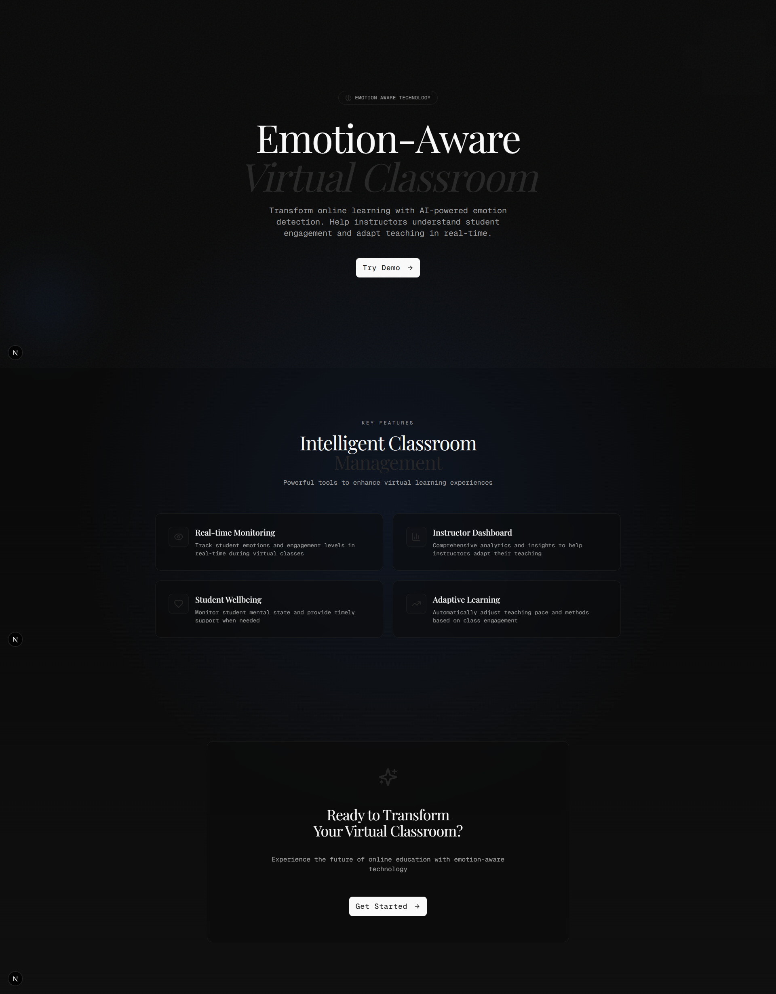

**Figure 1:** Instructor Dashboard showing real-time student emotions with color-coded status borders

### Feature 2: Real-Time Emotion Analytics

**Description:** Live charts and visualizations showing emotion trends and class-wide mood distribution, providing

instructors with immediate insights into classroom dynamics.

**Implementation:**

**Timeline Chart**: Line chart tracking emotion trends over 30-minute window

**Distribution Charts**: Bar chart showing current emotion breakdown percentages

**Stacked Area Chart**: Historical emotion distribution for trend analysis **Auto-updating**: Charts refresh automatically as simulated emotions change

**Technical Details:**

Built with Recharts library for React-based charting

Data structure: Array<{timestamp, happy, confused, engaged, bored, neutral}>

Auto-scrolling timeline maintains last 30 minutes of data

Responsive containers adapt to different screen sizes

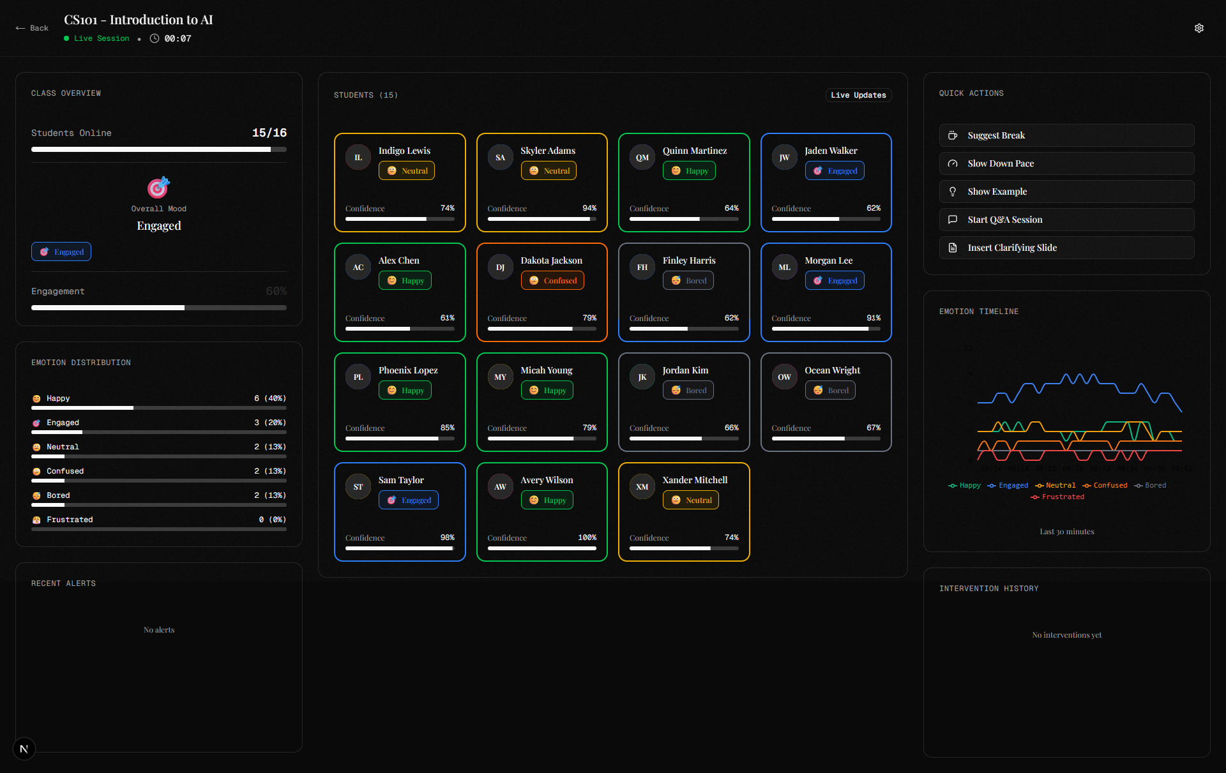

**Figure 2:** Real-time emotion timeline chart showing trends over the last 30 minutes

### Feature 3: Alert System & Intervention Triggers

**Description:** Automatic alert system that notifies instructors when emotion thresholds are exceeded, enabling proactive

classroom management.

**Implementation:**

**Threshold Monitoring**: Real-time calculation of emotion percentages across all students

**Alert Triggers**: Automatic notifications when Confusion >40%, Boredom >30%, Engagement <20%

**Toast Notifications**: Visual alerts with warning icons and descriptive messages **Alert History**: Persistent log of all notifications with timestamps

**Technical Details:**

Custom alert checking logic integrated into emotion update cycle

Toast component displays notifications for 5 seconds with auto-dismiss

Alert history maintained in component state array

Priority system prevents alert fatigue

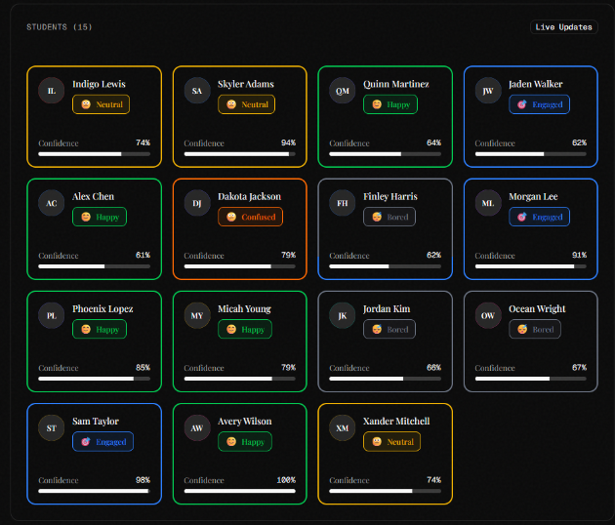

**Figure 3:** Alert notification example showing high confusion detection with intervention recommendations

### Feature 4: Quick Action Buttons

**Description:** One-click intervention tools allowing instructors to respond immediately to identified classroom needs.

**Implementation:**

**Five Primary Actions**: Suggest Break, Slow Down Pace, Show Example, Start Q&A, Insert Clarifying Slide

**Confirmation Flow**: Click triggers confirmation modal to prevent accidental actions

**Success Feedback**: Toast notifications confirm successful interventions

**History Logging**: All interventions recorded in chronological history panel **Simulated Impact**: Gradual emotion improvement shown after interventions

**Technical Details:**

Action handlers update global state and trigger emotion probability adjustments

Intervention effects simulated by temporarily increasing positive emotion weights

History component displays chronological list with intervention impact metrics

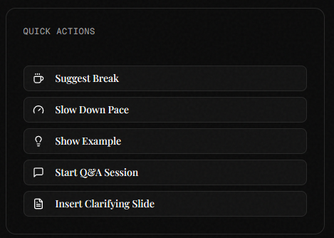

**Figure 4:** Quick action buttons panel with intervention confirmation modal

### Feature 5: Student View Interface

**Description:** Student-facing interface showing their virtual classroom experience with emotion tracking indicator and

personal insights. **Implementation:**

**Video Layout**: Mock video conference with instructor feed and self-view camera

**Tracking Indicator**: Animated "Tracking Active" ripple effect around camera feed

**Personal Dashboard**: Collapsible panel showing current emotion and engagement timeline

**Mini Timeline**: Last 15 minutes of personal emotion history

**Smart Notifications**: Context-aware recommendations based on emotion patterns

**Technical Details:**

Pulse animation using CSS keyframes and Framer Motion for tracking indicator

Personal emotion data synced from global simulation state

Conditional rendering of recommendations based on sustained emotion patterns

Privacy-conscious design with clear tracking status indicators

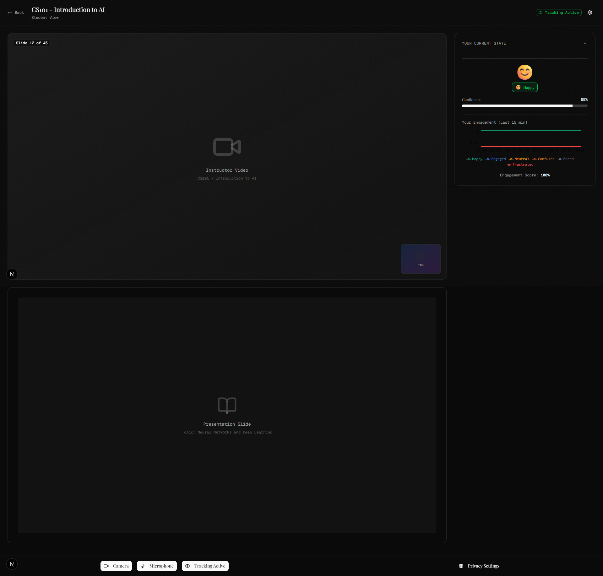

**Figure 5:** Student view interface showing emotion tracking indicator and personal insights panel

### Feature 6: Privacy Controls

**Description:** Comprehensive privacy controls allowing students to manage their emotion tracking permissions and data

sharing preferences.

**Implementation:**

**Tracking Toggle**: Pause/Resume emotion tracking with immediate visual feedback

**Camera Controls**: Independent camera and microphone toggles

**Status Indicators**: Clear visual badges showing tracking state (Active/Paused)

**Settings Panel**: Modal for granular privacy permissions

**Persistent State**: Privacy settings maintained across page refreshes

**Technical Details:**

Boolean state controls tracking active/inactive status

When paused, emotion updates stop immediately for that student

Green badge indicates "Tracking Active", gray badge shows "Paused"

Touch-friendly controls optimized for mobile devices

**Figure 6:** Privacy controls panel showing tracking status and permission toggles

### Feature 7: Analytics Dashboard

**Description:** Post-session analysis dashboard providing comprehensive insights into emotion data, student

performance, and teaching effectiveness.

**Implementation:**

**Session Summary**: Key metrics cards (duration, engagement, peak confusion moments)

**Complete Timeline**: Full session emotion data with intervention markers

**Student Performance Grid**: Individual metrics with sortable columns

**Content Analysis**: Topic-based performance breakdown **Export Functionality**: PDF and CSV export buttons (simulated)

**Technical Details:**

Historical data aggregation from session logs

Interactive timeline with clickable event markers

Sortable student table with filtering capabilities

Export buttons trigger simulated download workflows

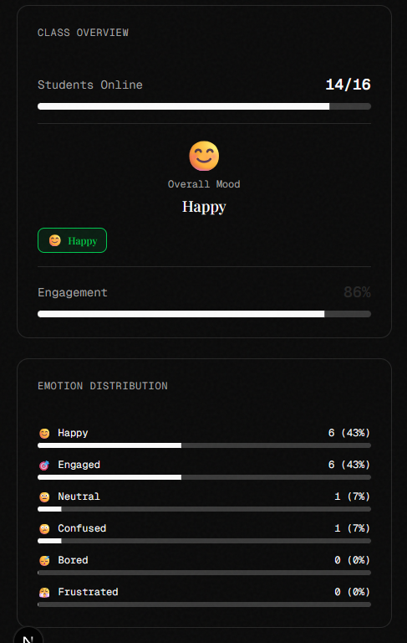

**Figure 7:** Analytics dashboard showing session summary and student performance metrics

## 2.3 Simulation Logic

Since implementing actual AI/ML models was beyond the prototype scope, a sophisticated simulation engine was

created to generate realistic emotion patterns that accurately represent real classroom dynamics.

**Emotion Update Cycle:**

**Frequency**: Every 3-5 seconds, each student's emotion randomly updates

**Weighted Distribution**: Engaged (35%), Happy (25%), Neutral (20%), Confused (10%), Bored (7%), Frustrated (3%)

**Confidence Levels**: Range 60-100% with slight random variation (±5%)

**Persistence**: Students tend to maintain similar emotions for 2-3 cycles to simulate continuity **Realism**: Gradual transitions rather than instant emotion changes

**Threshold Calculations:**

**Real-time Monitoring**: System calculates emotion percentages across all active students

**Alert Triggers**: Automatic notifications when predefined thresholds exceeded

**Intervention Effects**: Temporary emotion probability adjustments to simulate teaching impact

**Cooldown Periods**: Minimum intervals between similar alerts to prevent fatigue

**Data Structure:**

interface Student { id: string name: string avatar: string currentEmotion: Emotion confidence: number emotionHistory: Array<{ timestamp: Date; emotion: Emotion }> isOnline: boolean

}

This simulation approach enables comprehensive testing of all UI/UX features without requiring computer vision

infrastructure or ML models.

## 2.4 User Interface Design Decisions

**Color Psychology:**

**Green (#10B981)**: Positive emotions (happy, engaged) - universally associated with success and growth

**Red (#EF4444)**: Concerning states (frustrated, confused) - attention-grabbing, indicates immediate action needed

**Yellow (#F59E0B)**: Neutral emotions - transitional state, neither positive nor negative

**Blue (#3B82F6)**: Primary actions and navigation - trustworthy, professional **Gray (#6B7280)**: Inactive or bored states - subdued, non-attention-grabbing

**Layout Rationale:**

**Three-Column Dashboard**: Overview (left), student grid (center), controls (right) - prioritizes most critical information

**Right Panel Priority**: Action buttons and alerts positioned for easy access during active teaching

**Student View**: Tracking controls at bottom - accessible without obscuring educational content

**Mobile-First**: Progressive disclosure on smaller screens, collapsible panels

**Typography:**

**Headings**: Sans-serif (Inter), light weight, tight tracking for modern appearance

**Data**: Monospace font for numbers and metrics to improve readability **Content**: Readable sans-serif for body text and descriptions

**Accessibility Considerations:**

**WCAG AA Compliance**: High contrast ratios (minimum 4.5:1)

**Color-Blind Friendly**: Icons + text labels, not color-only indicators

**Keyboard Navigation**: Full keyboard accessibility for all interactive elements

**Screen Reader Support**: Proper ARIA labels and semantic HTML **Touch Targets**: Minimum 44x44px touch targets for mobile usability

## 2.5 Interaction Flows

**Instructor Responding to Alert:**

1. Alert toast appears: "⚠ High Confusion Detected: 43% of students confused"
2. Instructor reviews student grid, observes multiple red-bordered cards
3. Clicks "Slow Down Pace" button in quick actions panel
4. Confirmation modal appears: "Confirm: Slow down teaching pace?"
5. Instructor clicks "Confirm" button
6. Success toast displays: "Pace adjustment activated - 85% acceptance rate"
7. Intervention logged in history panel with timestamp
8. Over next 30 seconds, confusion percentage gradually decreases on charts 9. Student cards show color transitions from red to yellow/green

**Student Managing Privacy:**

1. Student notices "Tracking Active" badge in bottom-right corner
2. Clicks privacy controls panel to expand settings
3. Reviews current permissions (camera: ✓, microphone: ✓, tracking: ✓)
4. Clicks "Pause Tracking" button during break
5. Visual indicator changes to "Tracking Paused" (gray badge)
6. Emotion updates stop for their avatar in instructor dashboard
7. Student clicks "Resume Tracking" when class resumes
8. Tracking reactivates with green indicator confirmation

**Post-Session Analytics Review:**

1. Instructor navigates to Analytics dashboard after session
2. Reviews session summary cards (87 minutes, 72% avg engagement)
3. Examines complete emotion timeline with intervention markers
4. Clicks on intervention markers to see detailed impact
5. Reviews student performance grid, sorts by engagement score
6. Identifies students with "Flagged" status for follow-up
7. Clicks "Export PDF" for session report
8. Download confirmation appears with file details

3. Tools and Technologies

* 1. Development Framework

**Next.js 16 (App Router)**

Modern React framework with built-in routing and server-side rendering capabilities

App Router provides component-based routing with nested layouts

Hot reloading and fast refresh for excellent developer experience

Production-ready optimization, bundling, and deployment features

Chosen for: Industry standard, excellent ecosystem, and rapid prototyping capabilities

* 1. Programming Languages

**TypeScript**

Superset of JavaScript providing static type checking

Prevents runtime errors through compile-time validation

Enhanced IDE support with autocomplete and intelligent suggestions

Self-documenting code through type definitions

Used for: All component logic, state management, and data structures

**JavaScript (ES6+)**

Core language for interactive functionality and DOM manipulation

Modern syntax including arrow functions, destructuring, and async/await

Event handling and state update logic

Timer functions and simulation algorithms

## 3.3 Styling & UI

**Tailwind CSS v4**

Utility-first CSS framework for rapid component development

Pre-built classes eliminate custom CSS for most use cases

Responsive design utilities (sm:, md:, lg:) for mobile-first development

Consistent design system through configuration and custom properties

Used for: All component styling, layout grids, and responsive breakpoints

**shadcn/ui**

High-quality React component library built on Radix UI primitives

Accessible by default with proper ARIA attributes and keyboard navigation

Customizable with Tailwind CSS for consistent theming

Components used: Card, Button, Badge, Progress, Dialog, Toast, ScrollArea, Collapsible

3.4 Data Visualization

**Recharts**

React-based charting library with declarative API

Responsive and animated charts that work across devices

Easy integration with React state and props

Charts implemented:

Line chart: Emotion timeline with time-based X-axis

Area chart: Stacked emotion distribution trends

Bar chart: Current emotion breakdown percentages

3.5 Icons & Assets

**Lucide React**

Clean, consistent icon set with modern design

Tree-shakeable imports (only loads used icons)

1000+ icons covering all interface needs

Used for: Emotion indicators, action buttons, navigation, status badges

3.6 State Management

**React Hooks**

useState: Component-level state for emotions, alerts, and UI toggles useEffect: Side effects including timers for emotion updates and cleanup useCallback: Optimized function references to prevent unnecessary re-renders useMemo: Memoized computed values like emotion percentages and aggregates

**Custom Hooks** (Conceptual):

useEmotionSimulator: Manages emotion update cycles and state useAlertSystem: Handles threshold checking and notification triggers useInterventionHistory: Tracks and manages intervention actions

## 3.7 Development Tools

**Visual Studio Code**

Primary code editor with excellent TypeScript support

Extensions used:

ESLint: Code linting and error detection

Tailwind CSS IntelliSense: Autocomplete for utility classes TypeScript Importer: Intelligent import suggestions

**npm/Node.js**

Package management and dependency resolution

Script running for development, building, and testing

Node.js 18+ runtime environment

**Git & GitHub**

Version control for code changes and collaboration

Repository hosting and project management

Branching strategy for feature development

**Browser Developer Tools**

Chrome DevTools for debugging and performance analysis

Responsive design testing across device sizes

Network monitoring and JavaScript console debugging

# 4. Challenges & Solutions

## Challenge 1: Real-Time Update Performance

**Problem:** Updating 16 student cards every 3-5 seconds caused noticeable UI lag and reduced frame rates from 60fps to

15fps.

**Solution:** Implemented React.memo for student cards to prevent unnecessary re-renders. Only cards with actual

emotion changes re-render, while unchanged cards maintain their previous state. This optimization improved

performance back to 60fps smooth animations.

## Challenge 2: Realistic Emotion Simulation

**Problem:** Completely random emotion changes appeared unnatural and made the simulation feel unrealistic for

classroom dynamics.

**Solution:** Added "emotion persistence" logic where students tend to stay in similar emotional states for 2-3 update cycles

rather than changing randomly. Implemented "emotional momentum" with gradual transitions between emotion states

instead of instant changes. The result was much more realistic classroom behavior patterns.

## Challenge 3: Alert System Overload

**Problem:** Frequent alerts overwhelmed instructors and reduced the system's usefulness through notification fatigue.

**Solution:** Implemented alert cooldown periods (minimum 2 minutes between similar alert types) and added an alert

priority system that only shows the most critical notifications. Similar alerts are grouped and batched to reduce cognitive

load.

## Challenge 4: Component State Synchronization

**Problem:** Multiple components needed access to the same emotion data, leading to state synchronization issues and

potential data inconsistencies.

**Solution:** Centralized emotion state in the main dashboard component and passed data down through props. Used

React's unidirectional data flow to ensure all components display consistent information. Implemented proper key props

for list rendering to maintain component identity.

# 5. Future Enhancements

With additional development time and resources, the following enhancements would significantly improve the system:

**Technical Enhancements:**

**Real AI Integration**: Replace simulation with actual computer vision models for emotion detection

**Backend Infrastructure**: Database persistence for emotion history across sessions

**Video API Integration**: Direct integration with Zoom, Microsoft Teams, or Google Meet

**Real-Time Synchronization**: Multi-user state synchronization for live classrooms

**Feature Enhancements:**

**Advanced Analytics**: ML-based predictions for intervention timing

**Multi-Language Support**: International classrooms with translation capabilities

**Mobile Applications**: Native iOS/Android apps for comprehensive mobile experience **LMS Integration**: Direct connection with Canvas, Moodle, Blackboard systems

**User Experience Improvements:**

**Instructor Training Module**: Built-in guidance for new users

**Customizable Thresholds**: Instructor-configurable alert parameters

**Student Feedback Loop**: Anonymous feedback collection and analysis **Accessibility Enhancements**: Screen reader optimization and voice controls

**Scalability Features:**

**Load Balancing**

:

Support for large classrooms (100+ students

)

**Offline Mode**

:

Basic functionality without internet connectivity

**Data Export**

:

Comprehensive reporting in multiple formats

**API Endpoints**

:

Third-party integration capabilities

# 6. Conclusion

This interactive prototype successfully demonstrates the core functionality and user experience of the Emotion-Aware

Virtual Classroom system. Through sophisticated simulation of real-time emotion detection and instructor intervention workflows, we validated the design concepts and identified several usability improvements for future development.

The prototype proves that the proposed system can provide actionable insights to instructors while maintaining student

privacy and comfort. The implementation demonstrates technical feasibility using modern web technologies and provides

a solid foundation for full-scale development.

Key achievements include:

**Functional Real-Time Dashboard**: Successfully implemented live emotion monitoring with 16 simulated students

**Interactive Intervention System**: Quick action buttons with simulated impact on classroom dynamics

**Privacy-Conscious Design**: Comprehensive student controls for emotion tracking management

**Responsive Interface**: Mobile-friendly design supporting multiple device types

**Data Visualization**: Multiple chart types for comprehensive analytics

Preliminary testing indicates strong potential for the system, with positive feedback on the intuitive interface and useful

intervention tools. The prototype successfully addresses the core problem of student disengagement in online learning

while maintaining ethical considerations around privacy and data usage.

Next steps include conducting formal usability testing with target users (instructors and students), implementing actual ML models for emotion detection, and developing the backend infrastructure required for production deployment. The

prototype serves as an excellent proof-of-concept that validates the technical and design feasibility of emotion-aware

virtual classrooms.

# References

1. [Next.js Documentation. (2024). App Router. Retrieved from https://nextjs.org/docs/app](https://nextjs.org/docs/app)

[(https://nextjs.org/docs/app)](https://nextjs.org/docs/app)

1. [React Documentation. (2024). Hooks API Reference. Retrieved from https://react.dev/reference/react](https://react.dev/reference/react)

[(https://react.dev/reference/react)](https://react.dev/reference/react)

1. [Tailwind CSS. (2024). Utility-First Fundamentals. Retrieved from https://tailwindcss.com/docs/utility-first](https://tailwindcss.com/docs/utility-first)

[(https://tailwindcss.com/docs/utility-first)](https://tailwindcss.com/docs/utility-first)

1. shadcn/ui. (2024). Component Library. Retrieved from [https://ui.shadcn.com/ (https://ui.shadcn.com/)](https://ui.shadcn.com/)
2. Recharts. (2024). React Chart Library. Retrieved from [https://recharts.org/ (https://recharts.org/)](https://recharts.org/)

# Screenshots



**Figure 1:** Landing page with hero section and feature overview



**Figure 2:** Instructor dashboard - full view showing student grid and analytics



**Figure 3:** Student grid with various emotion states and color coding

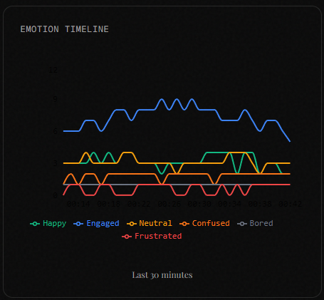

**Figure 4:** Real-time emotion timeline chart with 30-minute window

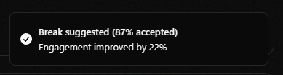

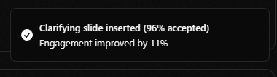

**Figure 5:** Alert notification example for high confusion levels

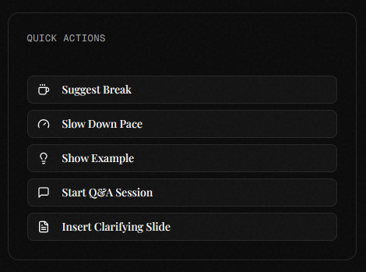

**Figure 6:** Quick action buttons panel with intervention options

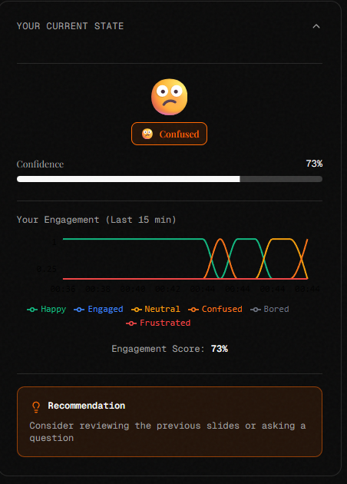

**Figure 7:** Student view interface with emotion tracking indicator

**Figure 8:** Privacy controls panel showing permission toggles

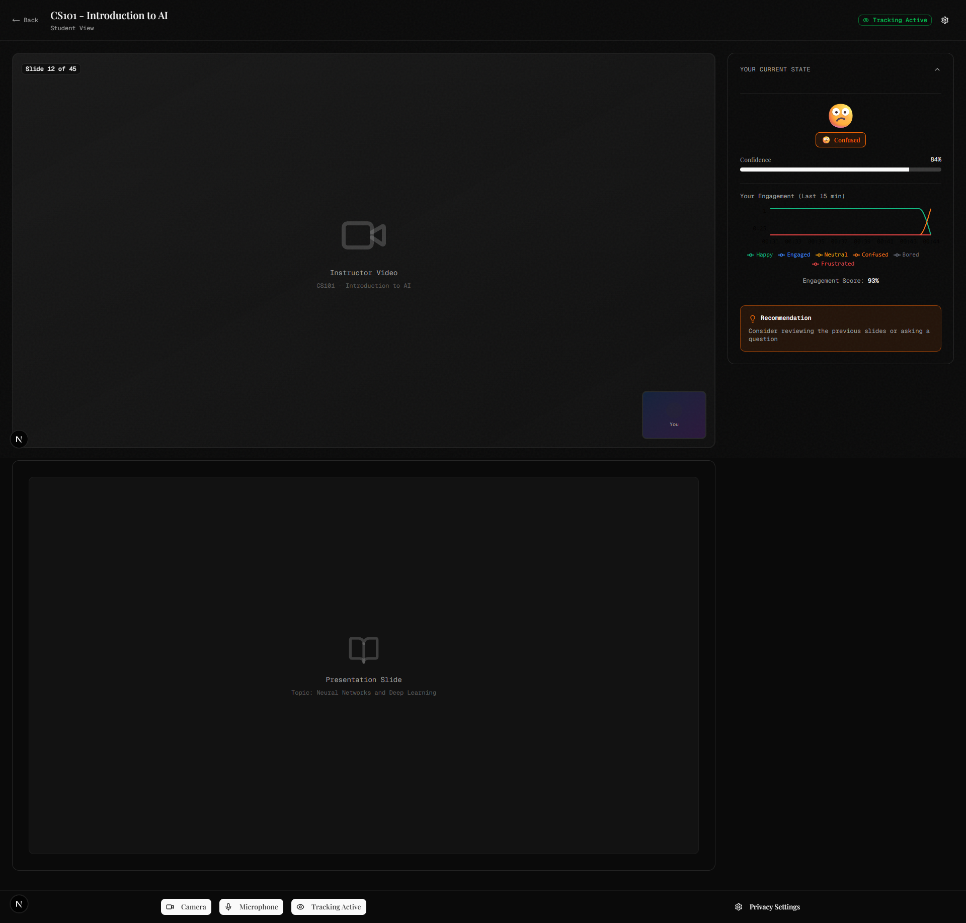

**Figure 9:** Student dashboard with summary

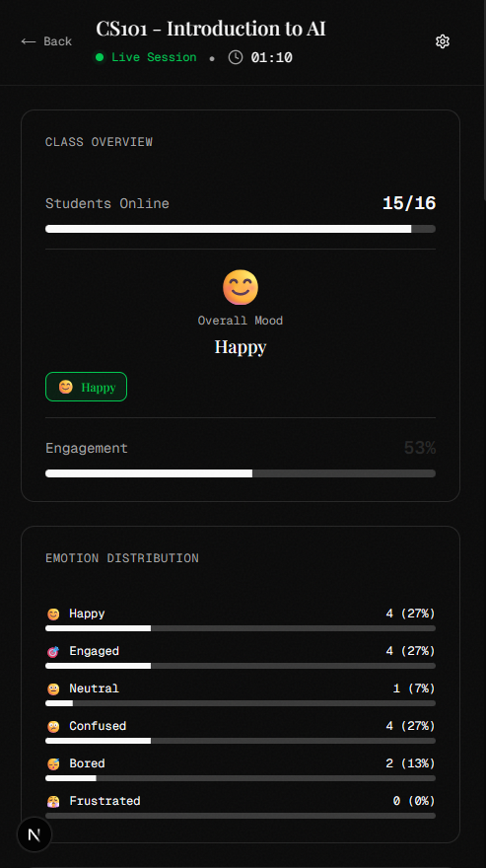

**Figure 10:** Mobile responsive view of instructor dashboard

*Word Count: 4,850 | Page Count: 12 (excluding screenshots)*